Willard Car Magnets are here!!
$5.00 each
All proceeds benefit the Emma Hart Willard PTO
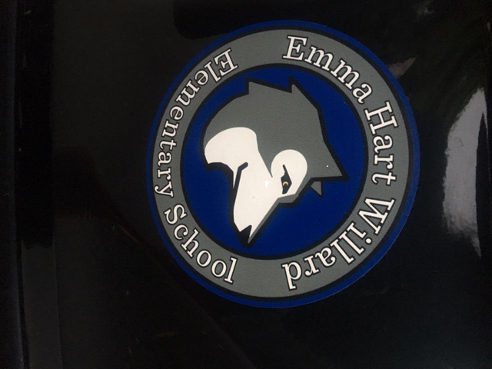
Please cut along the line and return the bottom portion to your child’s teacher or office in an envelope marked PTO car magnet

Child’s Name: _______________________________________________
Teacher: __________________________________________________
# of magnets:_______________________________________________
Amount enclosed:____________ (cash or checks payable to Willard School PTO)

