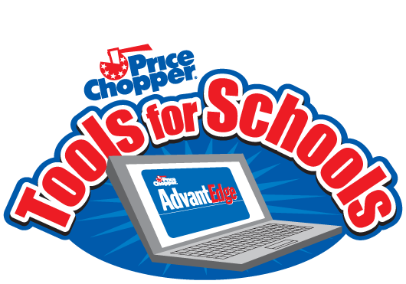

Hello Willard Families!
The Price Chopper Program is still running!! We have 86 shoppers registered and 6,777 points earned so far. This is GREAT but if you have not registered your card in the past please do so. The program runs from 08/13/2017 - 12/30/2017. Every time you shop at Price Chopper they award us school points which we can then shop from their catalog for various school items and equipment which go directly to your child’s classroom. We can collect points from ANY location Price Chopper, so if you have friends and relatives living out of town or state, it will benefit Willard for you to collect their number!
Last year we used our points to purchase new water color paints for the art classroom and washable markers.
All you need is the ten digit Price Chopper card number. The more cards registered, the more point earning potential we have. Just have your child return this sheet to school or you can use this link to register your card online. http://www.pricechopper.com/savings/tools-for-schools

10 digit Price Chopper Card #
__ __ __ __ __ __ __ __ __ __

Friends and Relatives
10 digit Price Chopper Card # 10 digit Price Chopper Card #
__ __ __ __ __ __ __ __ __ __ __ __ __ __ __ __ __ __ __ __

10 digit Price Chopper Card # 10 digit Price Chopper Card #
__ __ __ __ __ __ __ __ __ __ __ __ __ __ __ __ __ __ __ __

Thank you for supporting your Emma Hart Willard PTO.

